UK FRC communication on possible no-deal Brexit
On 21 February 2019, the UK FRC issued a communication for accountants and auditors in case of a no-deal Brexit exit. It sets out important issues to consider for businesses and auditors in both the UK and European Economic Area (EEA) countries (currently the 28 European Union (EU) member states plus Iceland, Norway and Liechtenstein). It also includes key actions for auditors and audit firms to get ready for the UK leaving the EU. It is a must-read for all in our profession who could be impacted by a no-deal Brexit exit.
FRC notice on accountants in case of a no-deal Brexit
This letter sets out important issues in relation to the future of accounting and corporate reporting in case the UK leaves the EU without a deal on 29 March 2019. While the Withdrawal Agreement brings into UK law International Accounting Standards already endorsed in the EU to provide continuity, the FAQs underline the main concerns linked to a no-deal scenario.
The UK’s government has recently issued the International Accounting Standards (IAS) and European Public Limited-Liability Company Regulations that sets out how new IAS issued by the IASB will be adopted for use in the UK after Brexit day. A future new UK body is excepted to be created and will assess new IAS for endorsement and new IAS in the process of being endorsed in the EU.

UK incorporated companies and groups

Annual accounts prepared using IAS as endorsed by the EU
For financial years straddling exit date, the government will ensure that these companies can continue to use EU-adopted IAS. UK incorporated companies will be required to use UK adopted IAS for financial years beginning after the 29th of March.

UK companies with cross-border presence in the EEA
UK incorporated parent companies with subsidiaries in the EEA should check the relevant reporting requirements in each EEA state, as the corporate reporting requirements of the UK’s Companies Act will not be automatically equivalent to the EU’s Accounting directive.
Relevant reporting requirements in each EEA States will also have to be checked.

UK public companies with UK listing
UK incorporated groups with securities admitted to trading on a UK regulated market can continue to use their accounts prepared with EU adopted IAS for all accounting periods before exit day. However, they will be required to use UK adopted IAS for accounting period after exit day.

UK public companies with EEA listing
UK incorporated group will need to comply with EU local regulatory provisions, on top of the requirement to produce accounts in the UK for domestic filing purposes. This may include the need to publish accounts using EU adopted IAS for the parent company or for the whole group.

Audit Committees
As mentioned earlier, all UK public Interest Entities will continue to be subject to the requirements in the Disclosure and Transparency Rules issued by the UK Financial Conduct Authority (FCA) and the UK Prudential Regulation Authority (PRA). Same changes to the audit directive will apply.

Appointment of auditors
An individual UK registered auditor will have to sign the audit report on behalf of the firm. Some rules relating to the approval of individuals and firms for registration as auditors will change: audit firms will receive an open letter on this topic from the government and the FRC.

EEA incorporated companies and groups

EEA companies and groups with cross-border presence in the UK
EEA companies with a UK incorporated subsidiary will no longer be eligible for certain exemptions from preparing and filing of accounts.
Such companies may be required to prepare group accounts and file them with UK Companies House unless they meet conditions of the UK Companies Act.
UK registered dormant companies with an EEA parent will have to prepare individual annual accounts for accounting periods beginning after exit date and file these with UK Companies House.

EEA public companies with UK listing
The government should issue an equivalence decision determining that EU-adopted IAS can continue to be used to prepare financial statements. This means that an EU incorporated group admitted to trading on a UK market will continue to be able to use accounts prepared based on EU adopted IAS.

Audit of the company
For all accounting years beginning after exit day, EEA companies admitted to trading on a UK regulated market will need to make sure that their EEA auditor is registered either as a statutory auditor in the UK, or as a third country auditor. After Brexit day, UK auditors’ registrations as EEA auditors may no longer be valid.

FRC notice on auditors in case of a no-deal Brexit
The FRC also published a set of key actions in relation to the future of auditors in case the UK leaves the EU without a deal on the 29 March 2019, in addition to the technical notice published back on 12 October 2018 by the UK government.
The FRC advices auditors on the significant changes a no-deal scenario will bring to the profession, with a FAQs presenting the major concerns linked to Brexit, which makes UK auditors becoming Third country auditors.

UK Audit firms and auditors

Recognition
Audit firms with a UK audit qualification have to contact each of the competent authority in the European Economic Area (EEA) States where they are currently approved to conduct EEA audit work.

If recognition continues:
If the EEA state gives its approval, no further action is needed.

If recognition ceases:
In this case, the firm has to re-establish its eligibility to carry out statutory audit work. This process may require:
- A compete new aptitude test, after Brexit day
- To requalify, that may include obtaining the relevant qualification in each country
In the hypothesis of a decision still pending on exit day, firms should contact the competent authority as recognition may cease and will imply a new eligibility process. New applications after 30 March 2019 will be made on the basis that a UK audit qualification will no longer be recognized as equivalent in EEA countries.
[We understand that the vast majority of EEA based audits by UK audit firms and auditors are located in Ireland and Luxembourg, with some in a number of other European Union (EU) Member States. These two countries have comprehensive systems for registration as a third country audit firm or auditor.]

On-going audits
If an audit report should be signed after Brexit day, the firm needs to contact the competent authority of the country where the company is incorporated to see if local laws allow the firm to continue this audit. If it is impossible and no further practical steps are available, it could be in the best interest of the client for the firm to resign as an auditor.
The same applies for group audits.

Third country auditors
After Brexit day, auditors working with UK incorporated companies will need to register as a third country auditor. As the application process can take time, the FRC advices to contact urgently the relevant national competent authority. That is why passing the audit to a partner or network firm may also be an option.
For company financial years beginning after 29 March 2019, all relevant companies incorporated in the EEA and listed on a UK regulated market will be required to appoint a registered Third Country Auditor or another firm which is eligible for appointment as a statutory auditor in the UK (see under EEA auditors below).

The EU audit regulation
The EU audit regulation will continue to apply in the UK, with certain amendments as ‘retained EU law’.
- It will continue to apply to banks, building societies, insurers and issuers of securities, admitted to trading on UK regulated markets.
- Previous Public Interest Entities issuing securities admitted to trading on EEA regulated market will no longer be treated as such for the purpose of the application of the EU audit Regulation.

Group audits
The FRC does not anticipate any significant issues in relation to carrying out the group audit that includes undertakings across both the EEA and the UK. Nevertheless, firms engaged in such groups should contact the competent authorities of the EEA States where the subsidiaries are incorporated to ask about any local restriction, including on sharing information outside the EEA.
Non-audit services on the blacklist under article 5 of the EU Audit Regulation will now be prohibited for all overseas subsidiaries. Firms in the same network as a UK auditor previously providing blacklisted services to non-EEA overseas subsidiaries will suffer the same prohibition.
Only UK parent undertakings are included in this prohibition. Non-audit services provided to an EEA parent undertaking of a UK entity are not included.

EEA Auditors

Existing registrations with UK recognised professional bodies
Registration will continue for existing statutory auditors who have registered with the UK recognized professional bodies based on having passed an aptitude test.
The UK government Technical Notice of 12 October 2018, Page 5, already clarified that audits of EU businesses seeking to raise capital by issuing shares or debt securities on a regulated market in the UK will need to be undertaken by an auditor registered with the UK FRC. The audits will need to be included in a cycle of inspections, in which the FRC will visit the registered auditor in the EU Member State where the business is incorporated until that Member State is recognised in the UK as having an equivalent audit regulatory framework.
Registration is needed for EEA auditors to continue to be able to issue audit reports for filing and use in the UK.
[We understand that 240 companies from 23 countries are impacted (from 21 EU member states and 2 EEA member states) as follows: Austria (2), Belgium (2), Bulgaria (1), Cyprus (4), Czech Republic (1), Denmark (7), Estonia (2), Finland (13), France (12), Germany (11), Greece (4), Hungary (3), Ireland (52), Italy (1), Luxembourg (15), Netherlands (37), Poland (3), Portugal (6), Slovakia (1), Spain (25), Sweden (24); Iceland (2) and Norway (12).]

New EEA registrations with UK recognised professional bodies until 31 December 2020
The UK offers unilaterally a transitional period for recognition of EEA auditors until 31 December 2020. EEA qualified auditors working in the UK that are not already registered as a statutory auditor have until this date to begin the process of obtaining eligibility to practice in the UK.
Auditors from the Republic of Ireland will not be affected, except the ones qualified as members of CPA Ireland.

Firm ownership
Until the 1 January 2021, all EEA auditors will continue to be eligible to be included in a UK firm’s required majorities of owners and managers.

Audit committees
All UK public interest entities will continue to be subject to the requirements in the Disclosure and Transparency Rules issued by the Financial Conduct Authority (FCA), and rules issued by the Prudential Regulation Authority (PRA) for an audit committee.
This requirement originally from the audit directive will be subject to changes:
- UK issuers of shares or debt securities that are only admitted to trading on EEA regulated markets will no longer be subject to this framework
- The current exemption for those businesses with a parent that is also subject to the same requirement will continue to apply, but only where the parent is incorporated in the UK.

Annex 1 – Audit Decision Tree
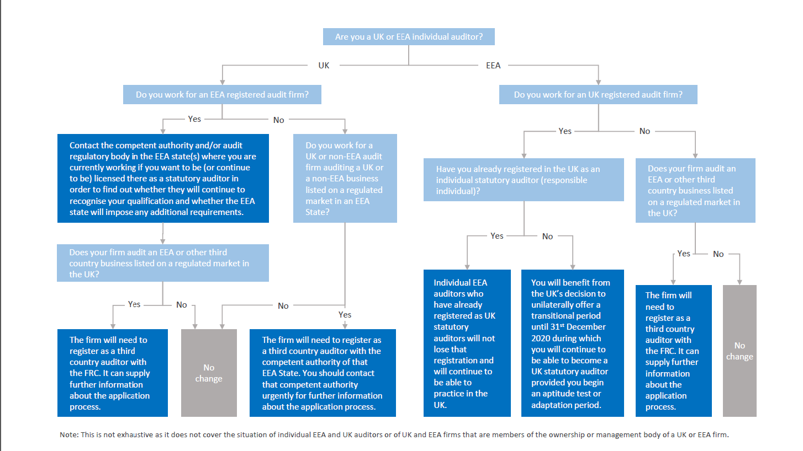

Based on the 2018 FRC Audit Quality Review inspection schedule. It is assumed that auditors of EEA companies listed on the UK AIM market are not impacted.

